Match the photo and the invention/innovation to the correct name:

1. The first electronic calculation machine used for the creation of the modern computer

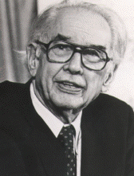

a. Ivan Notchev

b. John Atanasov

c. Rumen Antonov

d. Petar Petrov

Answer: b

2. The prototype of the digital electronic watch

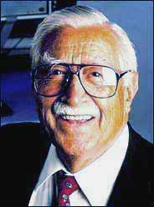

a. Petar Petrov

b. Georgi Bliznakov

c.Vladimir Dimitrov

d. Dimitar Paskov

Answer: a

3. Lactobacillus delbrueckii subspecies bulgaricus, bacteria for the production of yoghurt

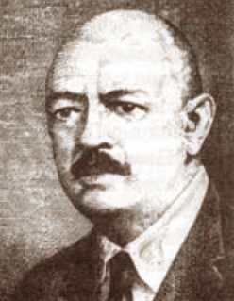

a. Blagovest Sendov

b. Vasil Gyuzelev

c. Dimitar Popov

d. Stamen Grigorov

Answer: d

4. In 2003 the Bulgarian astronomer and his team discover the most distant planet. It is 5000 light years away from the Sun. It`s located in the constellation of the Sagittarius and is called OGLE-TR-56b.

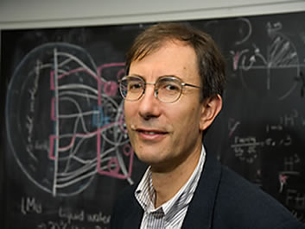

a. Dimitar Sasselov

b. Rumen Antonov

c. Nikolay Piperkov

d. Ivan Mitev

Answer: a

5. The First Bulgarian Plane

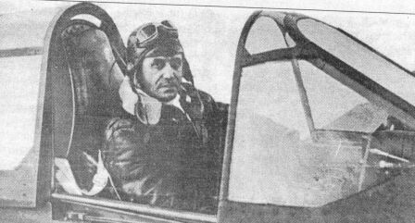

a. Asen Yordanov

b. Ivan Notchev

c. Dimitar Paskov

d. Georgi Nadjakov

Answer: a

**Sources:**

Information:

<http://en.wikipedia.org/wiki/List_of_Bulgarian_inventions>

<http://bg.wikipedia.org/wiki/%D0%A1%D1%82%D0%B0%D0%BC%D0%B5%D0%BD_%D0%93%D1%80%D0%B8%D0%B3%D0%BE%D1%80%D0%BE%D0%B2>

<http://www.borbabg.com/?action=news&news=3316>

<http://en.wikipedia.org/wiki/Asen_Yordanov>

<http://en.wikipedia.org/wiki/Dimitar_Sasselov>

Pictures

**John Atanasov**

<http://en.wikipedia.org/wiki/John_Atanasoff>

<http://bg.wikipedia.org/wiki/%D0%9F%D0%B5%D1%82%D1%8A%D1%80_%D0%9F%D0%B5%D1%82%D1%80%D0%BE%D0%B2_%28%D0%B8%D0%B7%D0%BE%D0%B1%D1%80%D0%B5%D1%82%D0%B0%D1%82%D0%B5%D0%BB%29>

**Petar Petrov**

<http://www.bulgarite.ca/canada/2008/petr-petrov-izobretatel-minava-prez-toronto-na-pt-za-sasch/>

**Stamen Grigorov**

<http://economymagazine.bg/news/6001/0/1/10-prichini-da-se-gordeem-che-sme-bulgari.html>

**Asen Yordanov**

<http://liternet.bg/publish/okela/ajordanov.htm>

**Dimitar Sasselov**

<http://www.doctortecno.com/noticia/las-5-noticias-que-te-haran-volver-sonar-con-las-estrellas>